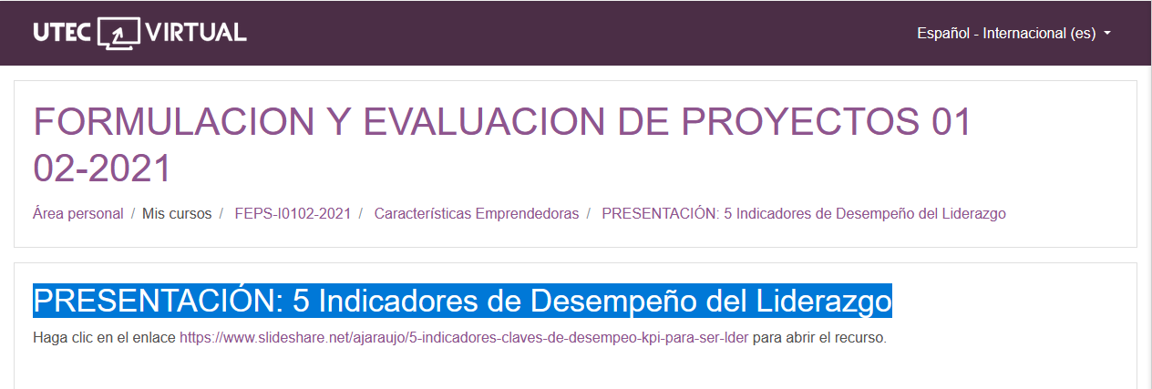

<https://www.slideshare.net/ajaraujo/5-indicadores-claves-de-desempeo-kpi-para-ser-lder>

<https://www.slideshare.net/ajaraujo/5-indicadores-claves-de-desempeo-kpi-para-ser-lder>